Software Requirement Specification

Memory Magic App

  - Release 1.0
  - Version 1.2
  - Prepared by Team Mesmerize.
Revision History
Revision Number | Date | Description | Approved by
1.0 | 08/11/2021 | Initial Release | Presley Muwan
1.1 | 09/14/2021 | Added and modified features based on feedback from the professor and mentors | Presley Muwan
1.2 | 10/10/21 | UI Screens update | Teresa Balbi

Table of Contents
1 INTRODUCTION 6
1.1 Purpose 6
1.2 Document Convention 6
1.3 Intended Audience 7
1.4 Product Scope 7
1.5 References 8
1.6 Definitions, Acronyms and Abbreviations 9
1.7 HIPPA Privacy Rule & HIPPA Security Rule 9
2 OVERALL PROJECT DESCRIPTION 10
2.1 Product Perspective 10
2.2 Product Features 11
2.3 Context Diagram 12
2.4 State Flow Diagram 12
2.5 User Classes and Characteristics 13
2.6 Operating Environment 13
2.7 Design and Implementation Constraints 13
2.8 User Documentation 14
2.9 Assumption and Dependencies 14
3 SYSTEM FEATURES 14
3.1 Access Permission to device resources 14
3.2 Activate and deactivate listening mode on button click. 15
3.3 Support for wake/sleep phrases 15
3.4 Add, modify, and delete Trigger words. 15
3.5 Listen and act on trigger words. 15
3.6 Transcribe and save notes 16
3.7 Notes can be sorted by date and grouped subject category 16
3.8 Add, Modify, and Delete Notes. 16
3.9 Large icons display for easy use 16
3.10 Notes are searchable by keyword or event date 16
3.11 On-boarding voice over assistance 16
3.12 Help 17
3.13 Cloud Support 17
3.14 Note Security 17
3.15 Support for Multiple languages 17
3.16 Notifications 17
3.17 Display events on calendar 17
4 EXTERNAL INTERFACE REQUIREMENTS 18
4.1 User Interface 18
4.2 Hardware Interface 33
4.3 Software Interface 34
4.4 Communication Interfaces 34
5 SYSTEM FEATURES/MODULES 35
5.1 Access Permission to device resources 35
5.1.1 Stimulus/Response Sequences 35
5.1.2 Functional Requirements 35
5.2 Activate and deactivate listening mode on button click 36
5.2.1 Description and Priority 36
5.2.2 Stimulus/Response Sequences 36
5.2.3 Functional Requirements 36
5.3 Support for wake/sleep phrases 36
5.3.1 Description and Priority 36
5.3.2 Stimulus/Response Sequences 37
5.3.3 Functional Requirements 37
5.4 Add, modify, and delete trigger words 37
5.4.1 Description and Priority 37
5.4.2 Stimulus/Response Sequences 37
5.4.3 Functional Requirements 39
5.5 Listen and act on trigger words 39
5.5.1 Description and Priority 39
5.5.2 Stimulus/Response Sequences 40
5.5.3 Functional Requirements 40
5.6 Transcribe and save notes 41
5.6.1 Description and Priority 41
5.6.2 Stimulus/Response Sequences 41
5.6.3 Functional Requirements 41
5.7 Add, Modify, and Delete Notes 41
5.7.1 Description and Priority 41
5.7.2 Stimulus/Response Sequences 42
Editing note 42
Delete Note 42
5.7.3 Functional Requirements 43
5.8 Notes can be sorted by date and organized subject category 43
5.8.1 Description and Priority 43
5.8.2 Stimulus/Response Sequences 43
5.8.3 Functional Requirements 44
5.9 Large icons for easy use 44
5.9.1 Description and Priority 44
5.9.2 Stimulus/Response Sequences 44
5.9.3 Functional Requirements 44
5.10 Notes are searchable by keyword and date 44
5.10.1 Description and Priority 44
5.10.2 Stimulus/Response Sequences 44
5.10.3 Functional Requirements 45
5.11 On-boarding assistance 45
5.11.1 Description and Priority 45
5.11.2 Stimulus/Response Sequences 45
5.11.3 Functional Requirements 46
5.12 Help 46
5.12.1 Description and Priority 46
5.12.2 Stimulus/Response Sequences 47
5.12.3 Functional Requirements 47
5.13 Cloud Support 47
5.13.1 Description and Priority 47
5.13.2 Stimulus/Response Sequences 47
5.13.3 Functional Requirements 48
5.14 Security Feature 48
5.14.1 Description and Priority 48
5.14.2 Stimulus/Response Sequences 48
5.14.3 Functional Requirements 48
5.15 Support for Spanish and English Languages 48
5.15.1 Description and Priority 48
5.15.2 Stimulus/Response Sequences 49
5.15.3 Functional Requirements 49
5.16 Notifications 49
5.16.1 Description and Priority 49
5.16.2 Stimulus/Response Sequences 50
5.16.3 Functional Requirements 50
5.16.4 Description and Priority 50
5.16.5 Stimulus/Response Sequences 50
5.16.6 Functional Requirements 50
6 EVENT TRIGGER KEYWORDS 51
6.1 Start Recording Event Trigger 51
6.2 Stop Recording Event Trigger Keywords 51
6.3 Playback Reminder Notes Event Trigger Keywords 51
6.4 Activation Triggers 51
6.5 Mic Deactivation Triggers 52
7 NONFUNCTIONAL REQUIREMENTS 52
8 Appendices 53
8.1 Credits 53

INTRODUCTION

Purpose
This Software Requirement Specification (SRS) document describes the software requirements (functional and non-functional) for release 1.0 of the Memory Magic App. This document is intended to be used by all members of Team Mesmerize to implement and verify the system's functionalities. Unless otherwise specified, all requirements presented in this document are high priority and committed for release 1.0.

Document Convention
The software to be developed shall serve as short-term memory (STM) assistant by augmenting the best features presented from the previous teams (Team Amazing, Team Bravo, and Team Charlie) with additional unique features, which includes:
- Support for Spanish (in addition to English).
- An option to enable security; leveraging the device security features (fingerprint biometric, facial recognition, or pin number)
- And an optional cloud storage support.
This SRS covers the system's core functionalities that will be in the system’s release 1.0.
This document follows the Software engineering standards committee of the IEEE computer society (1998) IEEE Recommended Practice for Software Requirements Specifications standard and references follow APA citations (7th ed.).

Intended Audience
This SRS document is intended for the Project Manager, Business Analyst, Developers, and Testers, on the Application team (Team Mesmerize) and Natural Language Processing team (team Triple Ts) members who will implement the system. The upcoming sections will cover the features of the system in detail.

Product Scope
The following requirements will be in scope as part of release 1.0 for the Memory Magic App:
- The application shall listen to speech when the user taps on the microphone button.
- Upon recognizing of user's voice and phrases, the system shall begin recording a text memo.
- The application shall recognize and ignore background voices and environmental noises.
- The application shall transcribe speech when key trigger phrases are mentioned.
- The system shall save transcribed notes on the user's device.
- The system shall identify notes by date or subject category.
- The application shall allow notes to be typed and edited.
- The application shall allow personal information to be saved as notes.
- The application shall have a flexible and functioning Graphical User Interface (GUI) with large, user-friendly icons.
- The application shall allow the user to customize and manage start, stop, and recall trigger words and phrases.
- The application shall allow notes to be searchable by keyword and date.
- The application shall provide a help menu.
- The application shall support cloud storage via google drive.
- The application shall allow the users the ability to set up note-access security by leveraging the device’s existing security features like; PIN, Finger Print, or Facial Recognition.
- The application shall support Spanish.
- The application shall support reminder notifications.

References
Baileys, A., Benavides, R., Cushing, B., Dunning, M., Mesfin, E., & Puschinsky, T. (2021, June 19). Software requirements specification: Harkify. University of Maryland Global Campus.
Brown, M. (2020, March 24). Capstone project guide. In SWEN 670. Retrieved from https://learn.umgc.edu/d2l/le/content/609389/viewContent/22442920/View
Famudehin, A., Broggin, C., Ahmed, C., Olshansky, M., Drammeh, M., Ballo, N., & Kelly, S. (2021, July 24). Software requirements specification: Memory enhancer application. University of Maryland Global Campus.
Five steps to HIPPA privacy rule compliance. (n.d.). In The Practice Solution. Retrieved from https://www.thepracticesolution.net/2005/05/05/five-steps-hipaa-privacy-rule-compliance/
Le, M., Jena, D., Johnson, A., Aboagye, P. A., Kimbi, D., & Sevilla, D. (2021, August 6). Software requirements specification: Mnemosyne, Disability Mobile Application. University of Maryland Global Campus.
Software engineering standards committee of the IEEE computer society. (1998, June 25). IEEE Recommended Practice for Software Requirements Specifications. In EEE Std 830-1998. Retrieved from http://www.math.uaa.alaska.edu/~afkjm/cs401/IEEE830.pdf
Wang, J. (2013, October 30). How do I become HIPAA compliant? (a checklist). In Truevault. Retrieved from https://www.truevault.com/blog/how-do-i-become-hipaa-compliant.html

Definitions, Acronyms and Abbreviations
Some of the terms used in this document are defined below:
Table 1
Acronyms and Definitions
Acronym | Definition
UI | User Interface.
GUI | Graphical User Interface.
SRS | Software Requirement Specification.
API | Abstract Programming Interface
STM | Short-Term Memory.
NLU | Natural Language Understanding.
NLP | Natural Language Processing.
HIPPA | Health Insurance Portability and Accountability
PHI | Protected Health Information
PII | Personal Identifiable Information

HIPPA Privacy Rule & HIPPA Security Rule
The HIPPA Privacy Rule establishes standards to protect a person’s medical records and PHI. The Magic Memory APP will adhere to the HIPPA Privacy Rule by keeping PHI secure and private, informing/supporting users of their rights, and limiting access to users’ information.

The HIPAA Security Rule requires appropriate Administrative, Physical, and Technical Safeguards to ensure the confidentiality, integrity, and security PHI. The Magic Memory APP will adhere to the HIPPA Security Rule by implementing technical safeguards such as access control and authentication, physical safeguards such as workstation security and disposal, and administrative safeguards such as risk analysis and risk management.

OVERALL PROJECT DESCRIPTION

Product Perspective
Short-term memory loss can occur for many reasons, leaving the sufferer in a state of disarray and unable to complete their everyday tasks. For those who suffer from this condition, notetaking is a key activity to maintain independent living. The notes range from reminder notes about daily activities, such as taking medication, to contextual notes such as people's names and backgrounds.
In order to meet the demand, the team will develop an application utilizing previous research that utilizes a state-of-the-art natural language processing and cloud-based technologies; users will be able to take notes at the press of a button. The primary technical goal is to enable users of the application to take notes and retrieve/edit them at a later point.
There are two primary stakeholders of the project:
- UMGC & SWEN670 – The University is the primary stakeholder – responsible for deciding the task, assigning the task, and being the ultimate grader of the deliverables.
- The User (Short Term Memory Disability) - This individual will complete user acceptance testing and be the target end-user.
The front-end application will communicate via an interface designed by the Tongue Twisters Team – such functionality to be determined.

Product Features
The list below includes the features that will be supported by release 1.0 of the system. Section 3 elaborates on these features.
FE-1: Access Permission to device resources.
FE-2: Activate and deactivate listening mode by voice.
FE-4: Activate and deactivate listening mode by voice.
FE-5: Listen and act on trigger words.
FE-6: Add, Modify, and Delete Trigger Word.
FE-7: Save transcribed notes.
FE-8: Add, Modify, and Delete Notes.
FE-9: Large UI icon displays.
FE-10: Search Notes.
FE-11: Help.
FE-12: Cloud Support.
FE-13: Security Feature.
FE-14: Multi-language Support.
FE-15: Notifications.

Context Diagram
Figure 1
Context Diagram
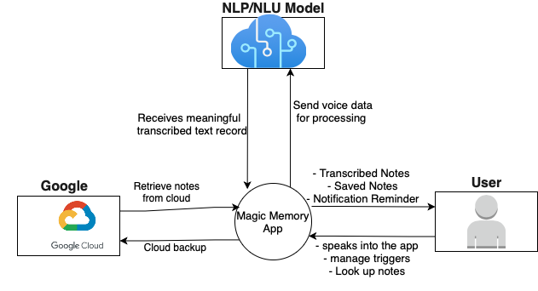

State Flow Diagram
Figure 2
State Flow Diagram
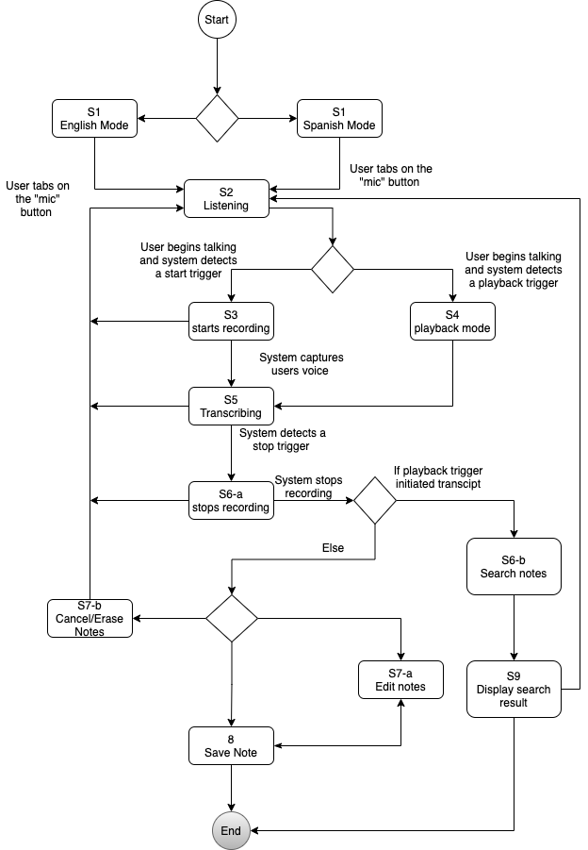

User Classes and Characteristics
Person with disability: This is the primary targeted user who will use the application as a short-term memory aid. Users in this category might not know how to operate phone, so the UI design must be simple to for them make it easy to learn and use.
In addition, these users might have other disabilities that prevent them from properly interacting with the app like, bad vision, limited range of motion, etc. All of these shall be considered in the design.
Developers: These are users who intend to update and maintain the systems. They will need access to the code base and other supporting document to understand the system’s implementation.

Operating Environment
OE-1: The Memory Magic application shall be designed to work on iOS and Android.

Design and Implementation Constraints
CO-1: The application shall support both English and Spanish.
CO-2: Support for the latest version of Apple iOS of Google Android shall be guaranteed. However, support for older version of these devices shall not be guaranteed.
CO-3: Devices will need to connect to the internet to use the application.
CO-4: The application shall have the ability to listen only if the user grants permission to the device’s mic.
CO-5: Users must have a google account to use cloud backup feature.

User Documentation
Upon delivery of the software artifacts, user documentation shall also be delivered and a link for that shall be made available in the application such that the user shall be able to review the documentation for assistance.

Assumption and Dependencies
AS-1: The end user must be the owner of a compatible device.
AS-2: The user’s device shall provide the Bluetooth capability needed to connect to a Bluetooth headset.
AS-3: The user’s device shall provide the aux port for headsets that use aux cable.
DE-1: Complete delivery of the app is dependent on successful QC and User Acceptance testing.
DE-2: Notes containing PII can only be protected if the user enable the use of the device security feature.

SYSTEM FEATURES

Access Permission to device resources
Given that the user has successfully installed the Memory Magic App on their device and launched it for the first time, the system shall prompt the user to permit the application to access their microphone and storage resources. If the user declines, the application shall not be able to function, and each time the application is launched, the user shall be reminded to provide permission to the required resources.

Activate and deactivate listening mode on button click.
Given that the user has installed and launched the Memory Magic app on their device, the mic can be activated by clicking the “mic” button. Once clicked, the app shall begin listening to the user.

Support for wake/sleep phrases
Given that the user has installed and launched the Memory Magic app on their device, the mic can be activated by saying a wake phrase like “hey memory magic”. And deactivated by saying the sleep phrase like “bye-bye memory magic.”

Add, modify, and delete Trigger words.
Given that the user has installed and launched the Memory Magic app on their device, they should have the ability to delete and modify existing trigger words and add new trigger words.

Listen and act on trigger words.
Given that the user has configured trigger words in the application and the application is actively listening to the user, upon the user saying a trigger word, the system should respond as follows:
- Start triggers – these words and phrases shall mark the point at which the app should begin Notes. And transcribed words before this point shall be excluded.
- Stop triggers - these words and phrases shall mark the point at which the app should end the notes. And transcribed words after this point shall be excluded from the saved note.
- Recall triggers – also known as playback triggers, are words and phrases that shall determine the start of a search key which the application will use to search or lookup notes to present to the user.

Transcribe and save notes
Given that the app is listening, and the user is talking, the Magical Memory app shall capture the user's voice, transcribe it to text format, and save it locally on the device.

Notes can be sorted by date and grouped subject category
Given that notes have been transcribed and saved, the application shall allow the user to organize notes by updated dates or by category grouping (notes belonging to the same categories shall be grouped today).

Add, Modify, and Delete Notes.
Given that the user has installed and launched the Memory Magic app on their device, the user will be able to add notes, modify existing notes, and delete existing notes.

Large icons display for easy use
Given that the user has installed and launched the Memory Magic app, the icon views of the app shall be large for visibility and accessibility.

Notes are searchable by keyword or event date
Given that users’ app has saved notes, upon inputting a keyword/phrase or event date via text, to search for notes, the application shall filter the notes and present matches to the user.

On-boarding voice over assistance
Given that the user has successfully installed the application when using the app for the first time, the app shall assist the user onboard, presenting the user with onboarding screens as well as voice-over text audibles to assist the user in the onboarding process. The app shall also receive voice commands from the user if they prefer to respond by voice.

Help
Given that the user has installed and launched the Memory Magic app, helpful information on how to use the application shall be accessible through the menu.

Cloud Support
Given that the user’s device is connected to the internet, and they own a Gmail account, they shall have the ability to back up their notes to google drive.

Note Security
Given that the user has installed and launched the Memory Magic app, they shall have the option to leverage the existing security feature in their device (like Pin entry, fingerprint biometric, or facial recognition) to access their notes; to ensure the privacy of the user's personal information captured in the notes.

Support for Multiple languages
Given that the user has installed and launched the Memory Magic app, they shall have the option to choose other text-to-speech supported language, other than English, as their primary language. And information displayed by the app shall be presented in the user's language of choice. Existing notes recorded shall not be translated if the user changes the primary language setting.

Notifications
Given that the user has an upcoming event in their note, the application shall notify the user within a one-hour window of the even happening.

Display events on calendar
Given that the user has successfully noted down events with the app, the user shall have access to a calendar view of their events that shows the date and time of each upcoming event.

EXTERNAL INTERFACE REQUIREMENTS

User Interface
The system user interface (UI) shall be an android UI that can be downloaded on the android smartphone.
Upon installing and first launching the app, the user shall be welcomed by an onboarding screen with voice-over-text speech support while assisting the user through the initial onboarding process. The onboarding screen will support voice commands for users who prefer voice input to button clicks, provided they permit access to the mic resources.
      - As the first step in the onboarding process, the app shall ask the user to select their primary language. All information presented from then shall be in the user’s language of preference.
      - Following the language selection, the app shall ask the user to permit it to access the device’s mic resources (and other resources needed by the app, if any).
      - Next, the app provides the user with an option to sign up for cloud back up service.
      - At the final step in the onboarding process, the app presents the user with a brief walkthrough tutorial on how to navigate the application.
Figure 1: Step1 in the onboarding process showing the language selection screen.
Figure 1
Language Selection
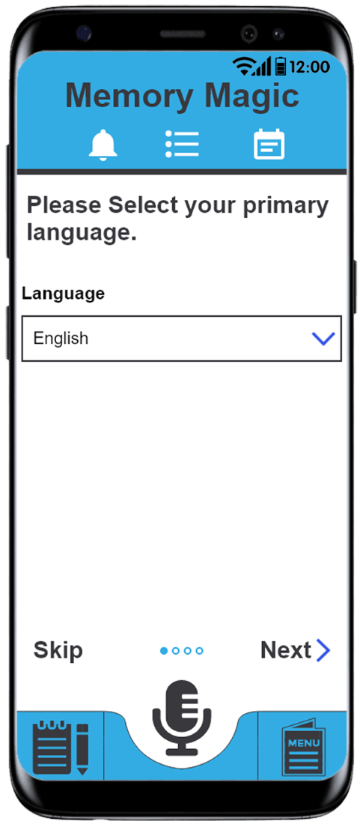

Figure 2: Step2 in the onboarding process showing the permission access screen.
Figure 2
Permission Access
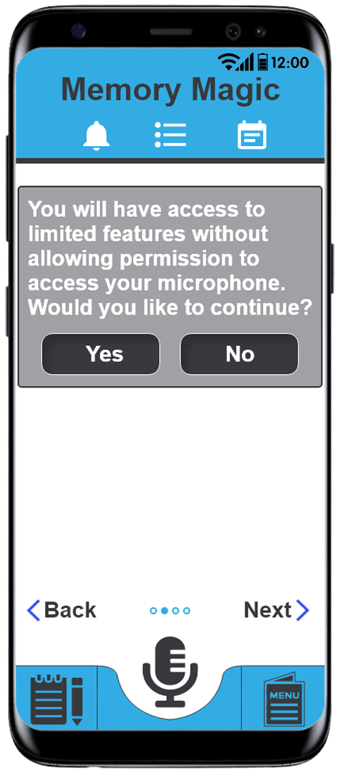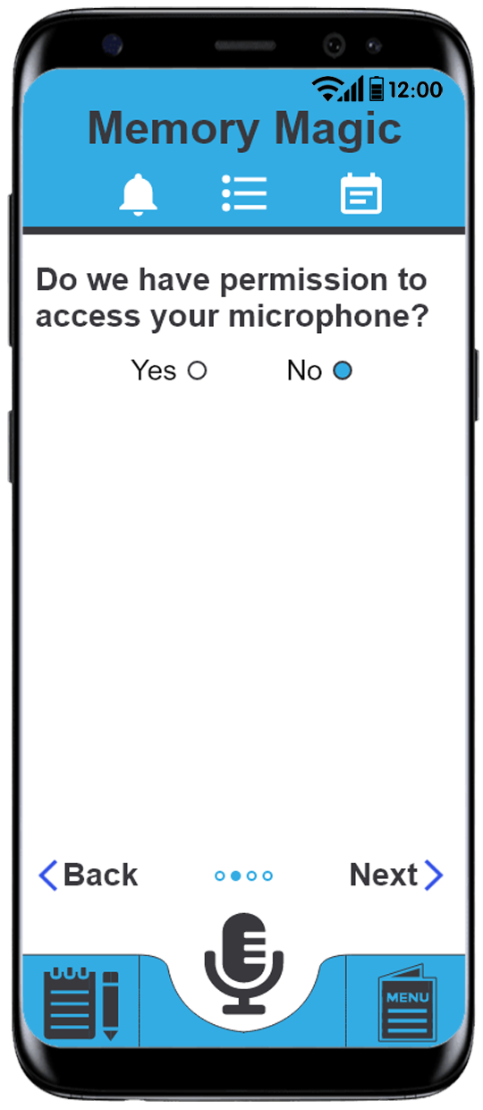

Figure 3: Step3 in the onboarding process – option to sign up with cloud backup.
Figure 3
Sign Up with Cloud Backup
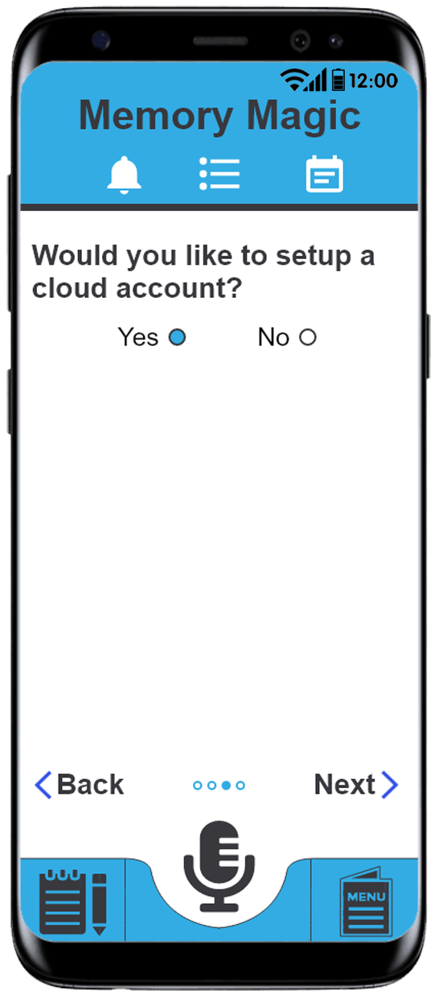

Figure 4: Step4 in the onboarding process – walkthrough tutorial.
Figure 4
Walkthrough Tutorial
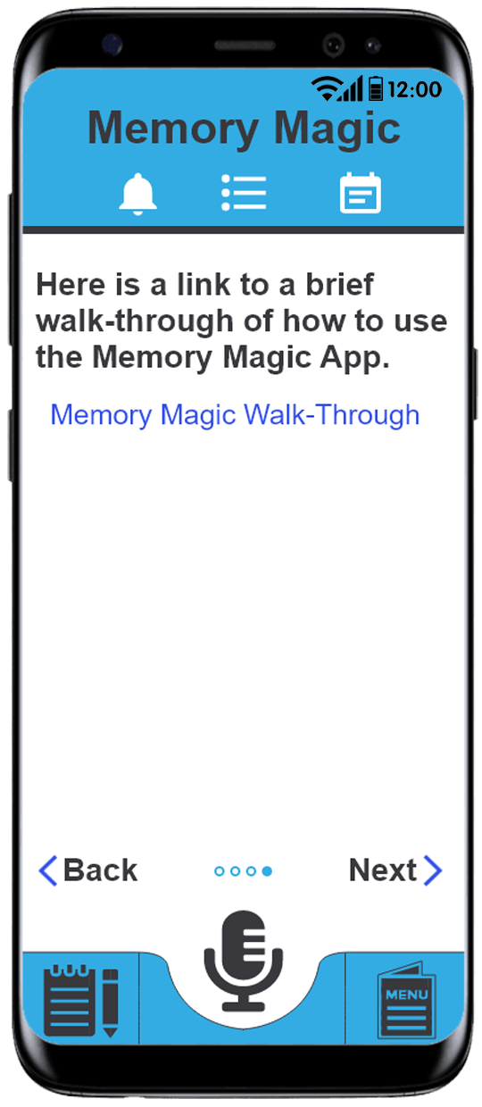
The main screen shall have a big microphone icon that allows the user to start recording as soon as he presses it. Then the application will transfer the voice into text and display it in the text field.
Figure 5- The home screen: shows the main page of the application.
Figure 5
Home Screen

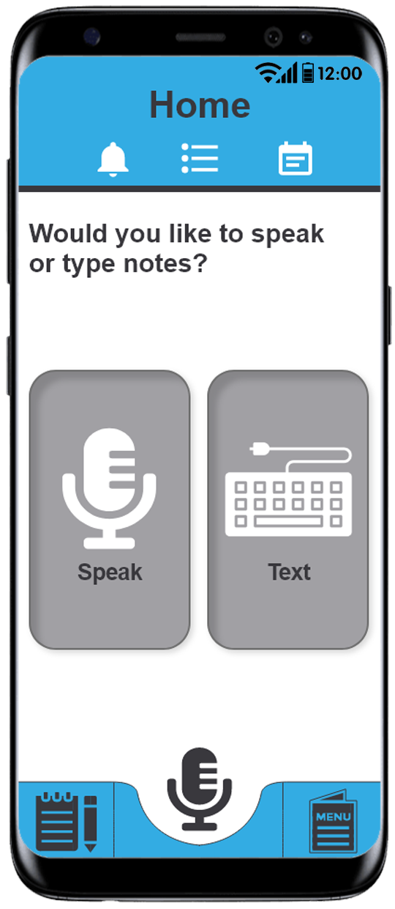
Once the user allows the application to access the microphone and record, the user will have the option to go to the menu, which is on the bottom of the main page. The menu shall have all the features the application has including Sync to cloud, Trigger, General Setting, and Help.
Figure 6- The menu screen: explains how the menu shall appear on the application.
Figure 6
Menu Screen
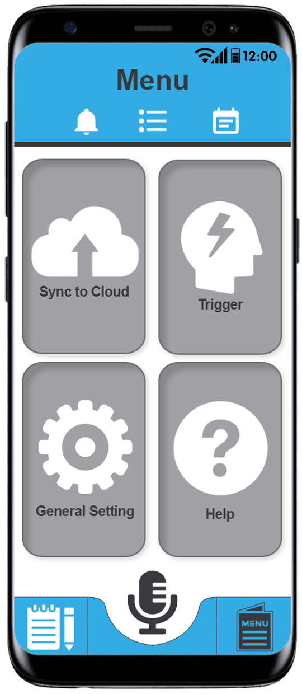
In the Trigger option, there shall be three fields:
- The first field shall allow the user to pick a trigger word to mark a note's start.
- The second field shall allow the user to pick a stop trigger word to mark the end of a note.
- The third field shall enable the user to pick a trigger word to playback the user's notes.
Figure 7- The Trigger screen: explains how the Trigger page shall look.
Figure 7
Trigger Screen
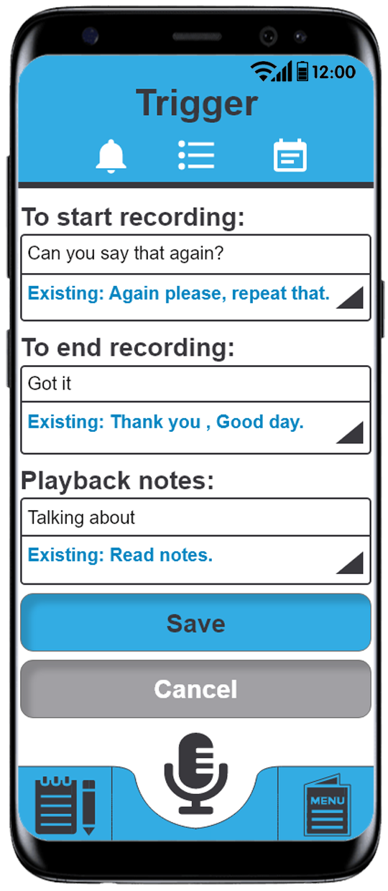

In the notes option, the user shall have the option to search for a specific note in the top search bar or to delete a note by simply clicking on the red “X” on the top right corner of the note. The user shall also have the option to add personal or random notes to the note page. The bottom of the page shall have four icons. The first icon shall allow the user to go back to the home page, while the second icon shall allow the user to go back to the menu page. The third icon shall allow the user to go to the general setting. The fourth option shall allow the user to go to the notes option.
Figure 8 - The notes screen: explains how the notes page shall appears on the application.

Figure 8
Notes Screen
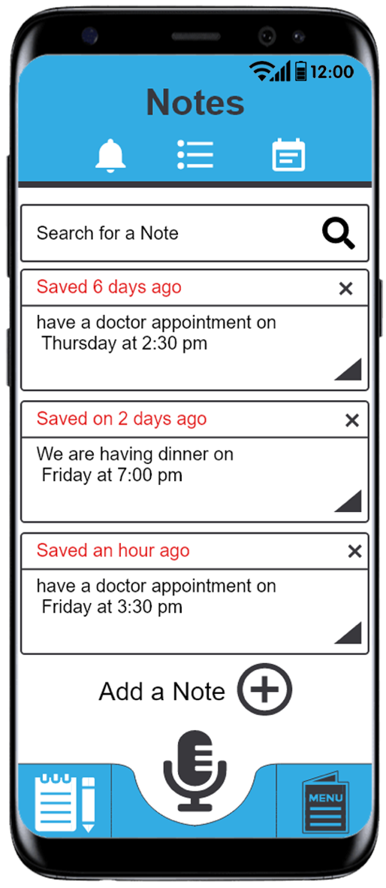

If the user decides he wants to delete a note, the application shall allow the user to do that by clicking on the top right red “X”. Then the application shall show a message to confirm that the user wants to delete the note.
Figure 9- delete a note: explains how the message shall appear when the user wants to delete a note.
Figure 9
Delete a Note
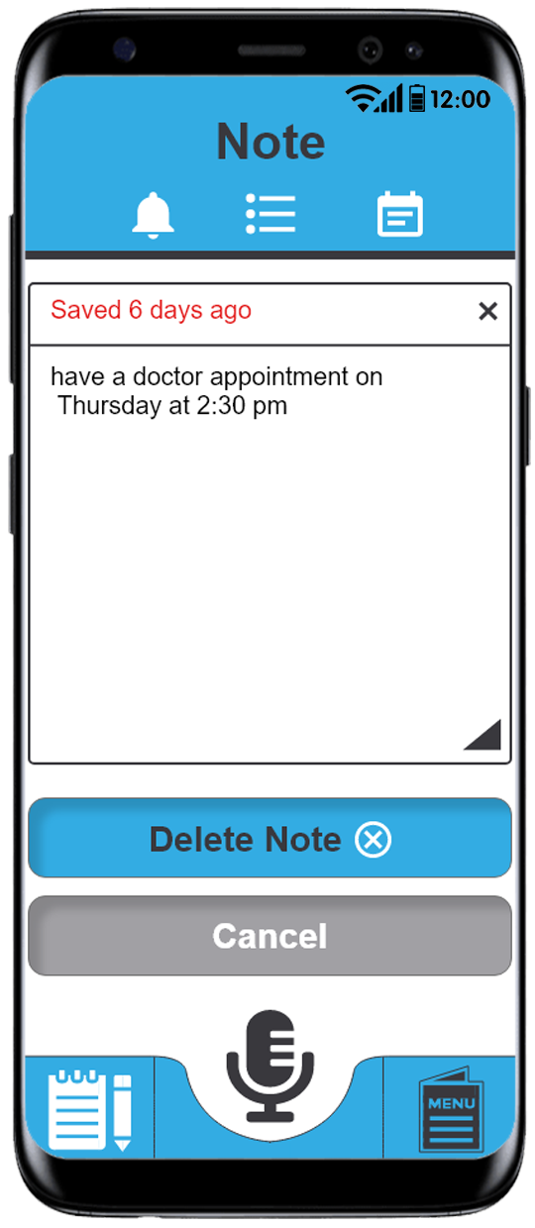

If the user decides to edit a note, the application shall allow the user to do so by clicking on the note. Once the user clicks on the note, a keyboard shall appear and allow the user to edit the note by typing on the keyboard. The application shall allow the user to save the changes or reset the changes.
Figure 10– Note detail screen: explains how editing the note shall be in the application.

Figure 10
Note Detail Screen
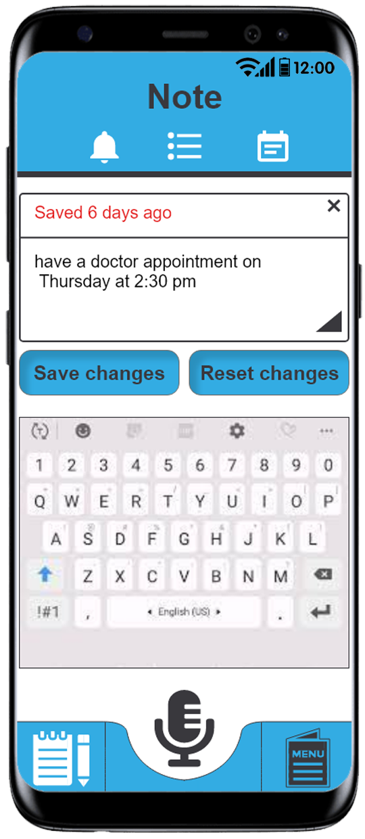

In the help option, the application shall answer all the questions the user has about the application and how it should work. The application shall give the user the ability to switch to the Spanish mode. The bottom of the page shall have four icons. The first icon shall allow the user to go back to the home page, while the second icon shall allow the user to go back to the menu page. The third icon shall allow the user to go to the general setting. The fourth option shall allow the user to go to the notes option.
Figure 11 explains how the help page shall look.
Figure 11
Help Screen
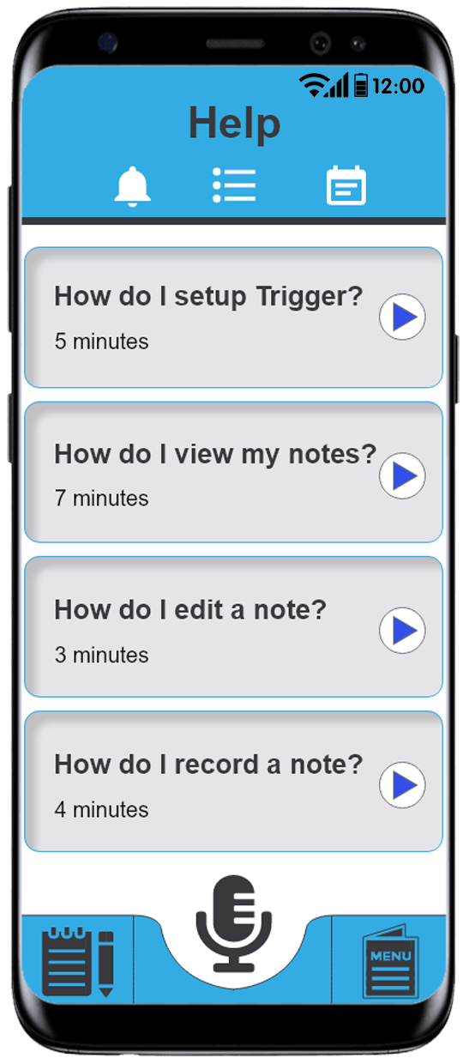
In the Sync to Cloud option, the user shall not be worried about losing his notes, because the application shall allow the user to upload his notes by logging into the cloud service. The application offers one options: Google Drive. The user shall click on the login button to login to cloud and upload the noted. The bottom of the page shall have four icons. The first icon shall allow the user to go back to the home page, while the second icon shall allow the user to go back to the menu page. The third icon shall allow the user to go to the general setting. The fourth option shall allow the user to go to the notes option
Figure 12 – Cloud setting screen: explains how the Upload to Cloud shall look.
Figure 12
Cloud Setting Screen
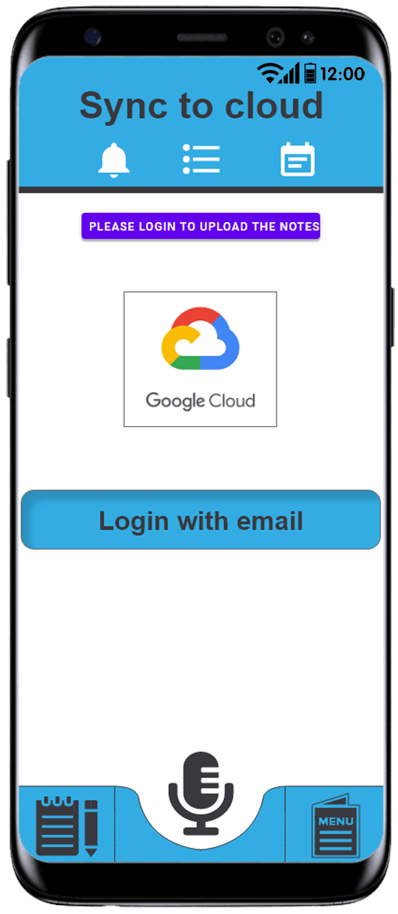
In the general settings, the user shall be allowed to change the font settings. It shall also allow the user to decide how many days he wants to save the notes on the application. There shall be a setting on the page where the user shall be allowed to change the application's language from English to Spanish and vice versa. Also, on this page, there shall be an option to change the application's security settings, where the user shall be allowed to enable the use of the device’s supported security features to secure access the notes.
Figure 13: illustrates how the general page should look.
Figure 13
General Setting
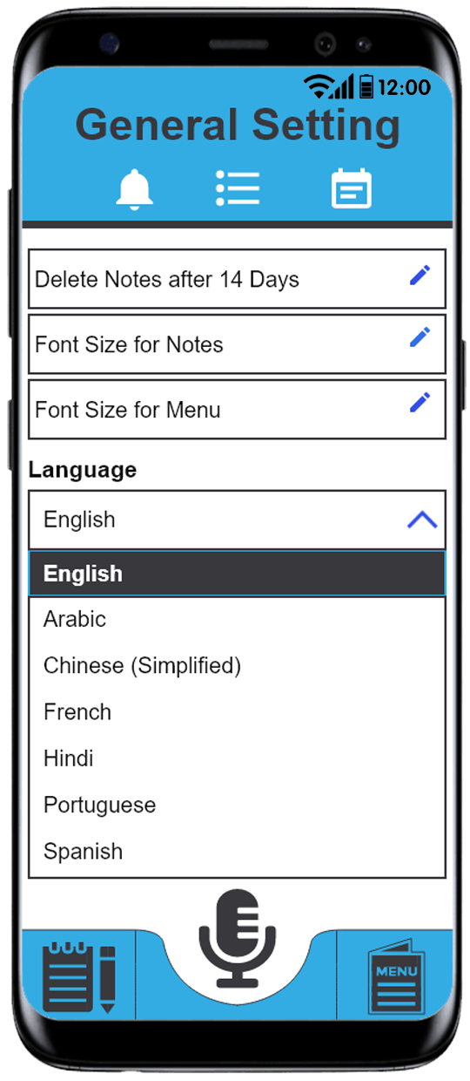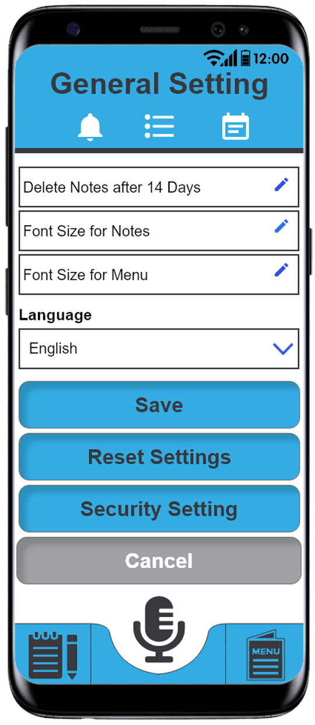

The final option is the security option. In this option, the user shall enable the user of the device’s existing security feature to protect the privacy of his notes. The bottom of the page shall have four icons. The first icon shall allow the user to go back to the home page, while the second icon shall allow the user to go back to the menu page. The third icon shall allow the user to go to the general setting. The fourth option shall allow the user to go to the notes option.
Figure 14: shows the security screen.
Figure 14
Security Screen
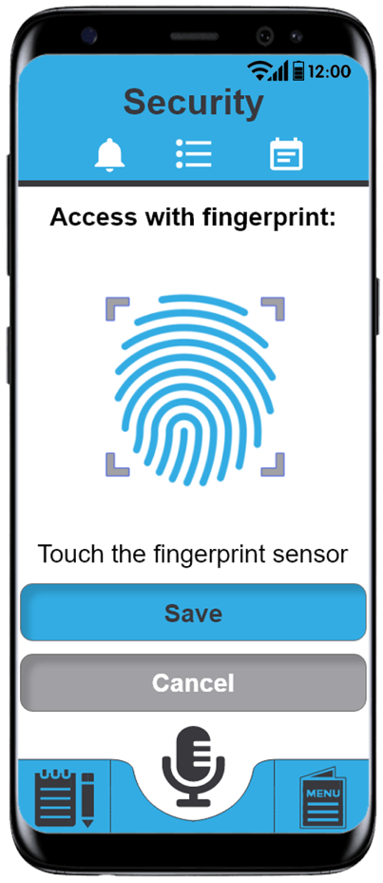
The Calendar screen shall be accessible from the to-right “calendar” widget. In this screen, the user can view the agenda that he has for each day based on the notes that were saved. Also, Memory Magic will send a notification before each created agenda to remind the user of their doctor appointments or dinners that he's having with his friend.
Figure 15: shows the Calendar screen.
Figure 15
Calendar Screen

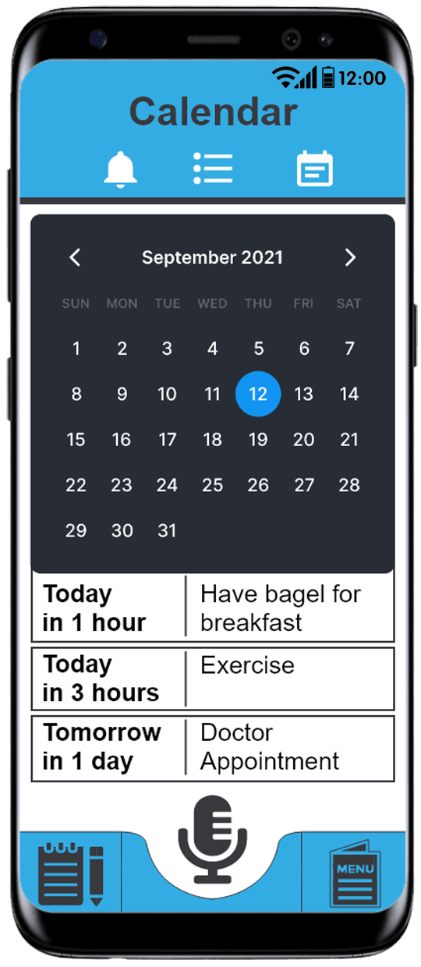

Hardware Interface
No hardware interface is needed for the application. The Memory Magic application shall install itself on the Android smartphone, and all the communication will be provided through the cloud service. So, there is no need for a hardware interface.

Software Interface
SI-1: The application shall be developed as an Android and iOS mobile application. The application shall be able to download on all android smartphones from Android 8 and up.
SI-2: The software shall be written using the Flutter platform, and the developer shall use the Dart library.
SI-3: The Android Studio will be used while writing the software code while using the flutter platform.
SI-4: The developer shall use SDK Manager while writing code to create a demo about the application and test it before publishing the application.
SI-5: The Android emulator shall be used to test the application in different screen sizes before publishing it to the user.
SI-6: GitHub shall be used to manage the code between teams, update the version of the application, and release the application.

Communication Interfaces
CI-1: The application shall allow the user to communicate through wired headphones or Bluetooth headphones.
CI-3: The application shall allow the user to hear from the speaker of the smartphone, the wired headphone, or the Bluetooth headphones.
CI-4: The application shall use the smartphone's internet connection to download notes or connect to the cloud service to upload the notes.
CI-5: The application shall make API calls to the NLU/NLP service to process and transcribe users’ vocal audio.

SYSTEM FEATURES/MODULES

Access Permission to device resources
Given that the user has successfully installed the Memory Magic App on their device and launched it for the first time, the system shall prompt the user to permit the application to access their microphone and storage resources.

Stimulus/Response Sequences
Stimulus: The user launches the app.
Response: The system checks if the app has permission to access the mic and storage resources.
Stimulus: The app does not have the necessary permissions.
Response: The system popup screen opens with the “permit” and “Cancel” buttons, asking the user to permit the app by clicking the “Permit” button.
Response: The user clicks on the “Permit” button.
Stimulus: The phone device grants Memory Magic App access to the mic and storage resource. If the user declines, the application shall not be able to function, and each time the application is launched, the user shall be reminded to provide permission to the required resources.

Functional Requirements
REQ-1.1: Upon launching the app, the system shall check if all necessary permissions to resources are granted.
REQ-1.2: The app shall provide an interface that the user can use to grant the app access to the system resources.

Activate and deactivate listening mode on button click

Description and Priority
Given that a user has successfully installed and launched the Magic Memory application, the user may activate or deactivate the app’s listening mode by clicking on the “mic” button (Priority-High).

Stimulus/Response Sequences
Stimulus: The user clicks the microphone icon when the app is not in listening mode
Response: The app turns on the mic to record audio.
Stimulus: The user clicks the microphone icon when the app is in listening mode
Response: The app turns off the mic to record audio.

Functional Requirements
REQ-2.1: Upon clicking the microphone icon when the app is not in listening mode, the app shall begin to listen to the audio.
REQ-2.1: Upon clicking the microphone icon when the app is in listening mode, the app shall stop to listen to the audio.
REQ-2.2: After clicking the microphone icon, the app shall display an indicator that the microphone is recording.

Support for wake/sleep phrases

Description and Priority
Given that a user has successfully installed and launched the Magic Memory application, the user may activate the app’s listening mode by saying “Hello Magic.” The user may also deactivate the app by saying “thank you magic” (Priority- Hight).

Stimulus/Response Sequences
Stimulus: The user says, “Hello Magic.”
Response: The app will turn on the mic to record audio.
Stimulus: The user says, “Thank you Magic.”
Response: The app will turn off the mic.

Functional Requirements
REQ-3.1: Upon saying “Hello Magic”, the app shall begin to listen to the audio.
REQ-3.2: If the app was already in Listening mode (with the mic turned on), the app should remind the user that it is already in listening mode, saying, “Hello Magic.”
REQ-3.3: Upon saying “Hello Magic,” the app shall inform the user that the listening mode has been activated and begin to listen to the audio.
REQ-3.4: Upon saying “Thank You, Magic,” the app shall stop to listen to the audio.
REQ-3.5: If the app was not already in Listening mode (with the mic turned off), there will be no response upon saying “Hello Magic.”

Add, modify, and delete trigger words

Description and Priority
Given that a user has successfully installed and launched the app, they may add, delete, or modify existing trigger words to start, stop, or recall notes. (Priority – High).

Stimulus/Response Sequences
Stimulus: The user navigates to the “home” menu and clicks on the “trigger” icon.
Response: The application opens the “Trigger” screen with an add, edit and delete button.

Adding trigger word
Stimulus: The user clicks on the “add” button from the “Trigger” screen.
Response: The system opens a text area accompanied by a save and cancel button.
Stimulus: The user enters the trigger word in the text area and clicks the save button.
Response: The system saves the new trigger word.

Modify trigger word
Stimulus: The user clicks on the “edit” button on a selected trigger word from the “Trigger” screen.
Response: The system opens a text area populated with the select trigger word, along with a “save and cancel” button.
Stimulus: If the user modifies the trigger word in the text area and clicks the save button.
Response: The system saves the modified trigger word.
Stimulus: If the user clicks on the “cancel” button.
Response: The system cancels the operation and returns the “Trigger” screen.

Delete trigger word
Stimulus: The user clicks on the “delete” button on a selected trigger word from the “Trigger” screen.
Response: The system opens a confirmation pop window with a “confirm” or “cancel” button asking to confirm or cancel deletions.
Stimulus: If the user clicks on the “confirm” button.
Response: The system deletes the targeted trigger word.
Stimulus: If the user clicks on the “cancel” button.
Response: The system closes the pop window and does not delete the trigger.

Functional Requirements
REQ-4.1: On the “Trigger” screen, there shall be an “Add” button that the user may use to add new triggers to the application.
REQ-4.2: On each trigger word label, there shall be an edit icon. When the Edit icon is clicked, a popup with an editable text area containing the current word. The user shall be able to change the text in this area.
REQ-4.3: After revising text, the user shall have an icon to save the revised word. There shall also be an icon to cancel any changes. After editing the trigger, it may be resaved using a Save icon.
REQ-4.4: Trigger labels shall have a delete icon. When the delete icon is clicked, a popup shall open with a confirmation to delete the trigger. The popup shall be an “Ok” button to agree with the deletion, and a Cancel button to close the dialog without deleting the trigger.
REQ-4.5: When the user clicks the ok button agreeing to deletion a trigger, the application shall delete the affected trigger word.

Listen and act on trigger words

Description and Priority
Given that the app is in listening mode, the application will listen for triggers that are set in the application and respond to them as expected. (Priority – High).

- Start triggers – shall mark the point at which the app should begin Notes. Every transcribed word before this point shall be excluded.
- Stop triggers – shall mark the point at which the app should end the notes. Every transcribed word after this point shall be excluded from the saved note.
- Recall triggers – shall determine the start of a search key which the application will use to search or lookup notes to present to the user.

Stimulus/Response Sequences
Stimulus: The user says start trigger word while the app is in listening mode.
Response: The application continues listening and transcribing text
Stimulus: The user says a stop trigger word.
Response: The application continuous to listen.
Stimulus: The user deactivates the applications from listening mode via a button click or by voice.
Response: The application stops listening, performs analysis on the transcript, and generates a note containing only words between the start and stop trigger words.

Functional Requirements
REQ-5.1: When the microphone is activated, the application shall listen for the start phrase and transcribe the user's speech when the user says this phrase.
REQ-5.2: While recording speech, the application shall stop transcribing notes when the user says the stop phrase.
REQ-5.3 When the user says the recall phase, the application shall find and playback the appropriate note.

Transcribe and save notes

Description and Priority
Given that the app is in listening mode while the user is speaking, the user's voice shall be transcribed to text, and a note shall be generated from the transcribed text and saved. (Priority- High).

Stimulus/Response Sequences
Stimulus: The user speaks while the app is in listening mode.
Response: The app listens to user’s voice and transcribes it to text.
Stimulus: The user stops speaking and deactivates the mic.
Response: The system analyzes transcribed text and generates notes.
Stimulus: The user clicks on the “save” button.
Response: The system saves notes.

Functional Requirements
REQ-6.1: The application shall have a save icon that appears after the user finishes transcribing speech.
REQ-6.2: Upon clicking the save icon, the application will save the note that was transcribed by the application.

Add, Modify, and Delete Notes

Description and Priority
Given that a user has successfully installed and lunch the app, they may add notes, modify or delete existing ones. (High Priority).

Stimulus/Response Sequences
Stimulus: The user navigates to the “notes screen” and tabs on a note.

Adding note
Stimulus: The user clicks on the “add note” button from the “notes screen”.
Response: The app opens a “add note” screen with a text area, and a “save” and “cancel” button.
Stimulus: The user add text in the text area and clicks the “save” button.
Response: The system saves the notes.

Editing note
Response: The app opens the note in an editable note text view containing “delete”, “edit”, “save” icons.
Stimulus: The user clicks Edit icon.
Response: Edit popup opens with the current text.
Stimulus: The user makes revisions and clicks on the save icon text.
Response: Application updates saved text with revisions.

Delete Note
Response: The app opens the note in an editable note text view containing “delete”, “edit”, “save” icons.
Stimulus: The user clicks “Delete” button.
Response: A popup appears to confirm the deletion.
Stimulus: User clicks ok with the confirmation to delete.
Response: The system deletes the note.

Functional Requirements
REQ-7.1: On the “Note” screen, there shall be an “Add” button that the user may use to add new notes to the application.
REQ-7.2: On each note, there shall be an edit icon. When the Edit icon is clicked, a popup with an editable text area containing the current note. The user shall be able to change the text in this area.
REQ-7.3: After revising the text, the user shall have an icon to save the revised text. There may also be an icon to cancel any changes. After editing the note, the revised note may be resaved using a Save icon.
REQ-7.4: Note labels shall have a delete icon. When the delete icon is clicked, a popup shall open with a confirmation to delete the note. The popup shall have an Ok button to agree with a “deletion” and “Cancel” button to close the dialog without deleting the note.
REQ-7.5: When the user clicks the ok button agreeing to deletion a note, the application shall delete the affected note.

Notes can be sorted by date and organized subject category

Description and Priority
Give that the app has a list of notes in the “notes screen”, the system shall order them by their updated dates and group them by contextual categories. (Priority - Low)

Stimulus/Response Sequences
Stimulus: The user clicks on the “Notes” icon from the navigation menu.
Response: The system lists the categories of notes ordered by the last updated timestamp.
Stimulus: The user tabs on one of the categories.
Response: The app shows a drop-down list of notes under the targeted category.

Functional Requirements
REQ-8.1: The application shall allow the user to sort a list of notes by date and group the notes by subject category.

Large icons for easy use

Description and Priority
Given that the app has been successfully installed and launched , throughout the application, there shall be large visible icons and text widgets to ease navigation and usage. (Priority – High).

Stimulus/Response Sequences
Stimulus: User launches app.
Response: The system displays a UI with large, clearly visible icons and text widgets.

Functional Requirements
REQ-9.1: The application shall have large icons to make them easier to find by those with memory issues.

Notes are searchable by keyword and date

Description and Priority
A search bar will be used to search the entered notes. Either a keyword or a date can be entered. The application will list the applicable notes after the search. (Priority-Medium).

Stimulus/Response Sequences
Stimulus: The user enters a search phrase and click the “Search” button.
Response: The application looks up the notes for the entered keyword or date.
Stimulus: The application finds a note that matches the search phrase.
Response: The application lists the search results .

Functional Requirements
REQ-10.1: A search bar shall be present in which the user can enter keywords or dates. After entering the keyword or date, the user can click a search button.
REQ-10.2: After the search button is entered, any notes matching the search keyword or date will be listed on the screen in the app. If there are no matching notes, there shall be a message indicating this.

On-boarding assistance

Description and Priority
Given that the user has successfully installed the application when using the app for the first time, the app shall assist the user onboard, presenting the user with onboarding screens as well as voice-over text audibles to assist the user in the onboarding process. The app shall also receive voice commands from the user if they prefer to respond by voice (Priority-High).

Stimulus/Response Sequences
Stimulus: The user launches the app for the first time.
Response: The system presents the user with a list of languages and asks the user, with voice-over-text instruction, to select a language.
Stimulus: The user selects their primary language from a list of languages.
Response: The system asks for the user’s permission to access the device’s microphone. And presents the button options of “Decline” or “Confirm”.

Stimulus: The user selects “confirm” or “declines” to permit the app to access the device’s mic. If the user declines access, the app shall inform them that voice interaction shall not be activated.
Response: With a voice-over-text ask, the system request for the user to optionally sign up for cloud backup while presenting the user with the options to “Proceed” or “Skip” step.
Stimulus: The user opts to skip cloud backup by clicking the “skip” button or saying “skip cloud backup.” If the user chooses to set up cloud backup, the system will proceed as described in section 5.13.
Response: The user is presenting with an introductory walk-through video that shows how to navigate the app. In addition, the user is provided with the option to “skip” the introductory video.
Stimulus: Introductory video finishes, or the user skips it.
Response: The app presents the home screen.

Functional Requirements
REQ-11.1: The application shall be granted mic permission to receive voice commands from users.
REQ-11.2: The system shall have a working set of speakers to support the voice-over-text assistance.

Help

Description and Priority
Given that the user has installed and launched the Memory Magic app, helpful information on how to use the application shall be accessible through the menu (Priority-Medium).

Stimulus/Response Sequences
Stimulus: The user navigates to the home menu and clicks the “Help” button.
Response: The system opens help screen.
Stimulus: The user clicks on a topic.
Response: The system opens the topic.

Functional Requirements
REQ-12.1: The application shall have a help area that will be linked from any screen in the application.
REQ-12.2: The application shall have help documents for various topics such as to help the user learn how to use the application.

Cloud Support

Description and Priority
Given that the app is connected to the internet and the user has a google account, the user may sync their notes to the cloud such that they can access them from another device (Priority-Low).

Stimulus/Response Sequences
Stimulus: User clicks Storage Settings.
Response: The system presents the user with the “Google Drive” icon.
Stimulus: User clicks on the “Google Drive” icon.
Response: The application ask the user to sign into google with their google account.
Stimulus: The user signs in successfully.
Response: The system saves the current state of the user’s note in google drive.

Functional Requirements
REQ-13.1: There shall be a storage setting that the user may use to set up cloud storage with their google account.

Security Feature

Description and Priority
Given that a user has successfully installed and launched the app, the user may enable the user of their device’s supported security feature to access their notes to secure the privacy of their personal information (Priority-Medium).

Stimulus/Response Sequences
Stimulus: The user clicks on the “enable security” button in Settings.
Response: The app checks for the supported security feature in the device. And presents the user with the options (Fingerprint, Facial recognition, or PIN number – if support)
Stimulus: The user selects the security feature to use.
Response: The app calls the device API to setup the selected security.

Functional Requirements
REQ-14.1: The user’s device shall support at least one security feature which is accessible to apps via API calls.

Support for Spanish and English Languages

Description and Priority
Given that a user has successfully launched the Memory Magic app, they may select the language of choice of English or other supported languages in the app’s settings (Priority-Medium).

Stimulus/Response Sequences
Stimulus: The user clicks Language Settings.
Response: The application opens the Language Settings page.
Stimulus: The user selects a language (English or other supported languages) and clicks the Save button.
Response: The application saves the setting and presents the text widgets and audios in Spanish.

Functional Requirements
REQ-15.1: In the application settings, there shall be a language settings option. The default option shall be English, with the alternate option as Spanish.
REQ-15.2: If the language setting is Spanish, any menus or screens should be in Spanish, and any transcribed speech shall be in Spanish. If this setting is changed, any already transcribed notes shall remain in the language they were originally transcribed in, but the menus and screens will be changed accordingly.

REQ-15.1: The default language option will be English.

Notifications

Description and Priority
Given that the user has notification turned on and has an upcoming event in their note, the application shall notify the user within one hour of the event. The notification shall be titled with the type of event.

Stimulus/Response Sequences
Stimulus: The user’s event just crosses the one-hour window.
Response: The system creates a notification reminding the user they have an even in one hour.
Stimulus: The user clicks on the notification.
Response: The system presents the user with a note containing details of the events.

Functional Requirements
REQ-16.1: The system shall keep track of event dates and times and remind the users, within a one-hour interval, when the event is due.
REQ-16.2: The system shall provide an interface for the user to enable or disable notifications.

Description and Priority
Given that the user has successfully noted down events with the app, the user shall have access to a calendar view of their events that shows the date and time of each upcoming event.

Stimulus/Response Sequences
Stimulus: The user creates an event for a specific date and time.
Response: The system detects the date and time of the event.
Stimulus: The user opens the calendar by clicking on the “calendar” widget.
Response: The system opens a Calendar UI displaying the event along with its date and time.

Functional Requirements
REQ-16.1: The system shall auto-detect, and display on the calendar, note events with dates and/or time information.
REQ-16.2: The app shall provide a widget for accessing the calendar UI.

EVENT TRIGGER KEYWORDS

Start Recording Event Trigger
This section lists out the keywords that will trigger the system to mark the start of the user’s note in a transcript.
- “Start Recording.”
- “Remind me to…”
- “I should remember to…”

Stop Recording Event Trigger Keywords
This section lists out the keywords that will trigger the system to mark the end of the user’s note in a transcript.
- “Okay, it noted”
- “I got it”
- “That is all for now.”

Playback Reminder Notes Event Trigger Keywords
These keywords will trigger the system to begin capturing the search key that will be used to lookup related notes.
- Mic A“Talking about…”
- “I don’t remember…”
- “Referring to...”

Activation Triggers
These are keywords and phrases that, when uttered, the applications will switch to listening mode by turning on the mic.

- “Hey Memory Magic…”
- “Hi Memory Magic…”
- “Hello, Memory Magic...”

Mic Deactivation Triggers
These are keywords and phrases that, when uttered, the applications will switch of listening mode by turning off the mic.
- “Thank you, Memory Magic,…”
- “Bye-bye Memory Magic…”

NONFUNCTIONAL REQUIREMENTS
Storage
NF-1.1: System shall not record or store the user’s voice.
NF-1.2: Notes shall be stored locally in an SQLite database.
NF-1.3: The users shall have the option to back up their notes on google cloud.

Performance
NF-2.1: UI responses to user interaction shall not exceed 2 seconds.

Security
NF-3.1: All external communication shall be encrypted
NF-3.2: The application shall not require user authentication but shall have an option for the users to secure their notes (including notes with PII) by leveraging their device’s supported security features like; pin number, fingerprint, and facial recognition
NF-3.3: Cloud storage shall require the user’s cloud account for authentication.
NF-3.4: The application shall follow HIPAA Privacy Rules by restricting access to PHI information to the user and individuals who have a specific need for the information.
NF-3.5 The application shall not share any of the recorded voice or saved data with any external sources other than the designated cloud storage to limit the risk of sharing Personal Identifiable Information (PII).
NF-3.6 The application shall only be available on official app stores.

Quality
NF-4.1: The system shall support English and Spanish.
NF-4.2: The system shall comply with 508 specifications to ensure that it is easy to use by individuals with a disability.
NF-4.3: Only transcriptions with a minimum of 85% confidence shall be stored.
NF-4.4: The system shall filter background noise and focus only on the user’s voice.
NF-4.5: Users who enable cloud storage shall access their backed-up notes from any device connected to the internet.

Maintainability
NF-5.1: There shall be design documents that shall capture the business and technical requirements of the system.
NF-5.1: Documents shall be revisited and updated before proposed changes are made to the system.

Appendices

Credits

Below are the members that contributed or will contribute to the development of this application:
- Dr. Mir Mohammed Assadullah
- Roy Gordon
- Johnny Lockhart
- Jeroen Soeurt
- Michelle Monfort
- Robert Wilson
- Ayodeji Famudehin
- Chauntika Broggin
- Christian Ahmed
- Mitchell Olshansky
- Mod Drammeh
- Nicholas Ballo
- Shawn Kelly
- Raul Benavides
- Maddison Dunning
- Alec Baileys
- Benjamin Cushing
- Elshaday Mesfin
- Tyler Puschinsky
- Michael Le
- Debashis Jena
- Austin Johnson
- Prince Antwi Aboagye
- Didimus Kimbi
- Damion Sevilla
- Rebecca Johnson
- Addisu Worku
- Matthew Setiawan
- Obinna Okonkwo
- Andrew Rohn
- Joseph Kalfus
- Firehiwot Chari
- Eskedar Endashw
- Malik Webster
- Leela Subramanian
- Presley Muwan
- Christian Cruz Jimenez
- Daniel Avery
- Karen Crumb
- Kevin Bell
- Sami Salim
- Teresa Balbi
- Endalkachew Girma

